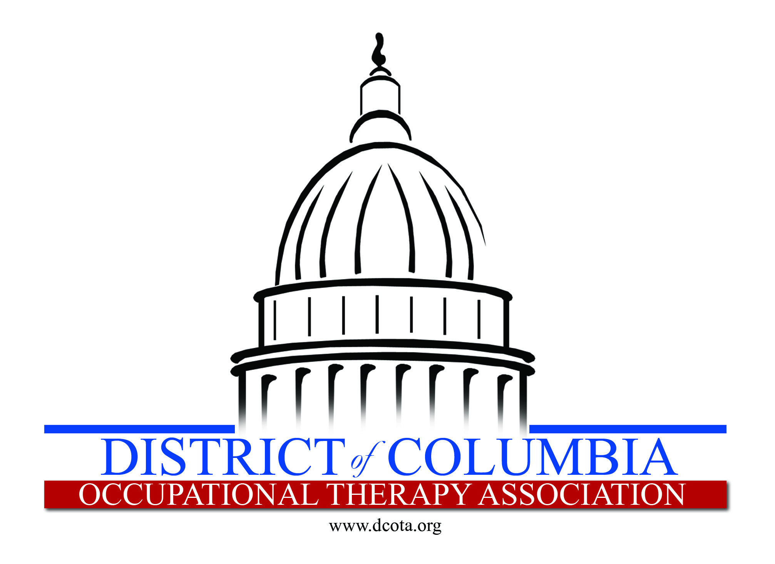

Call for Papers
DCOTA Bi-Annual Conference
April 13, 2019
Trinity Washington University
125 Michigan Avenue, NE
Washington, D.C. 20017

DCOTA Bi-Annual Conference: Occupational Therapy Moving Full STEAM AHEAD
OT = #STEAM Science, Technology Engineering, Arts and Mathematics

Requested Topics
The Theme for this Year is #OT=is=STEAM: Science, Technology, Engineering, Arts and Mathematics. Your presentation should reflect one of these subject areas and how it plays a role in the occupational therapy advancement of Vision 2025: Occupational therapy maximizes health, well-being, and quality of life for all people, populations, and communities through effective solutions that facilitate participation in everyday living.

We are seeking content experts in the subject areas listed below as it relates to occupational therapy practice areas , please consider submitting a proposal for the 2019 Bi Annual Conference. Science, Technology, Engineering Arts & Math are the stated topics.

Directions for Submitting Proposals
1) Review the Call for Papers directions carefully listed below
2) Send any questions or concerns to info@mydcota.org
3) Ensure that all sections of the Call for Papers have been completed
4) Send the COMPLETED PROPOSAL PACKET to info@mydcota.org by Monday January 9, 2019.

Policies Governing Accepted Proposals
Please agree to the "Policies Governing Accepted Proposals" and keep a copy for your reference.

Once a proposal is accepted as a session, changes to the proposal may not be made.
DCOTA reserves the right to assign the time that accepted proposals will be scheduled during the one day conference
All speakers whose proposals are accepted for presentation must register for the conference.

Notification will be sent by e-mail to the primary presenter regarding acceptance of proposals. Notifications not acknowledged by the due date, will result in a session being dropped from the final program and considered for our year round hot topic series.
Copyrights, Royalties, and Trademarks - Speaker warrants that no literary or artistic work or other property protected by copyright will be performed, reproduced or used, nor will the name of any entity protected by trademark be reproduced or used by Speaker during your speech and presentation (including but not limited to any exhibits, movie clips, videos, graphics) unless Speaker has obtained written permission from the copyright or trademark holder. Speaker covenants to comply strictly with all laws respecting copyright, royalties and trademarks.
Speaker shall indemnify and hold DCOTA, its officers, agents and employees harmless from all claims, losses and damages (including court costs and attorney fees) with respect to any such copyright, royalty or trademark rights. Visit www.copyright.com

Standard audiovisual equipment will be available as follows for each session except Poster Sessions:
l laptop computer w/DVD/CD player and MS Office
l podium
l 1 projection screen
l 1 LCD projector
l Sound system
l Internet Connection

Presenters are encouraged to provide a session handout.
I understand and accept the policies and deadlines for proposal submission. _____

I. PROPOSED SESSION TITLE
Be concise and descriptive. (Maximum character limit is 120 including spaces).

Title of Proposed Session: Click here to enter text.

II. SESSION FORMAT
Breakout Session: 70-75-minute with reflective time for attendees.

III. LEVEL OF MATERIAL
Introductory level is geared to practitioners with little or no knowledge of the subject matter. Focus is on providing general introductory information.
Intermediate level is geared to practitioners with a general working knowledge of current practice trends and literature related to the subject matter. Focus is on increasing knowledge and competent application of the subject matter.
Advanced level is geared to practitioners with a comprehensive understanding of the subject matter based on current theories and standards of practice as well as current literature and research. Focus is on recent advances and trends, and/or research applications. It is expected that a high-level of participation by attendees is encouraged during this session.

Please select the level of material being presented:
Introductory
Intermediate
Advanced
Please state why you selected this level: Click here to enter text.

IV. PRIMARY CATEGORY
Please select a primary focus that best describes your proposal.

Please select a primary focus: Science, Technology , Engineering and Math as well as the related area of occupational therapy practice it relates to
Academic & Fieldwork Education
Children & Youth
General & Professional Issues
Health & Wellness
Mental Health
Productive Aging
Rehabilitation, Disability, & Participation
Work & Industry

VI. LEARNING OBJECTIVES
Should be specific and answer the question: "At the conclusion of this session, participants will:" This may have up to 3 learning objectives.

Objective 1: Click here to enter text.
Objective 2: Click here to enter text.
Objective 3: Click here to enter text.

VI. ABSTRACT AND REFERENCES
The scoring of your proposal depends upon following the submission criteria closely and completely. Reviewers will use this information to score your submission. Combined abstract and references character count limit for each session type is below:

•Breakout Session 3,500 (includes spaces)
• Poster 2,500 (includes spaces)

Please enter abstract and references: Click here to enter text.

VII. ABSTRACT SYNOPSIS
Summarize the major points of your abstract and describe how this topic will advance either the professional development of the participant or the field of occupational therapy. If your proposal is accepted, this information will be printed in the conference program guide.
Maximum character limit: 300 (including spaces): Click here to enter text.

VIII. SPEAKER INFORMATION
Please note: The primary speaker is the only person who will receive notifications from DCOTA regarding acceptance of the proposal.

Primary Speaker
First Name: Click here to enter text. Last Name: Click here to enter text.
Degrees/Credentials: Click here to enter text.
Employer: Click here to enter text.
City: Click here to enter text. State: Click here to enter text.
Phone: Click here to enter text.
Email Address (all correspondence will be sent to this email.): Click here to enter text.
Speaker Bio (100 words or less): Click here to enter text.

Additional Speaker(s)

1.
First Name: Click here to enter text. Last Name: Click here to enter text.
Degrees/Credentials: Click here to enter text.
Employer: Click here to enter text.
City: Click here to enter text. State: Click here to enter text.
Phone: Click here to enter text.
Email Address (all correspondence will be sent to this email.): Click here to enter text.
Speaker Bio (100 words or less): Click here to enter text.
2.
First Name: Click here to enter text. Last Name: Click here to enter text.
Degrees/Credentials: Click here to enter text.
Employer: Click here to enter text.
City: Click here to enter text. State: Click here to enter text.
Phone: Click here to enter text.
Email Address (all correspondence will be sent to this email.): Click here to enter text.
Speaker Bio (100 words or less): Click here to enter text.
3.
First Name: Click here to enter text. Last Name: Click here to enter text.
Degrees/Credentials: Click here to enter text.
Employer: Click here to enter text.
City: Click here to enter text. State: Click here to enter text.
Phone: Click here to enter text.
Email Address (all correspondence will be sent to this email.): Click here to enter text.
Speaker Bio (100 words or less): Click here to enter text.

